MAIN PAGE
uPVC (Vinyl) SIDING & SOFFIT
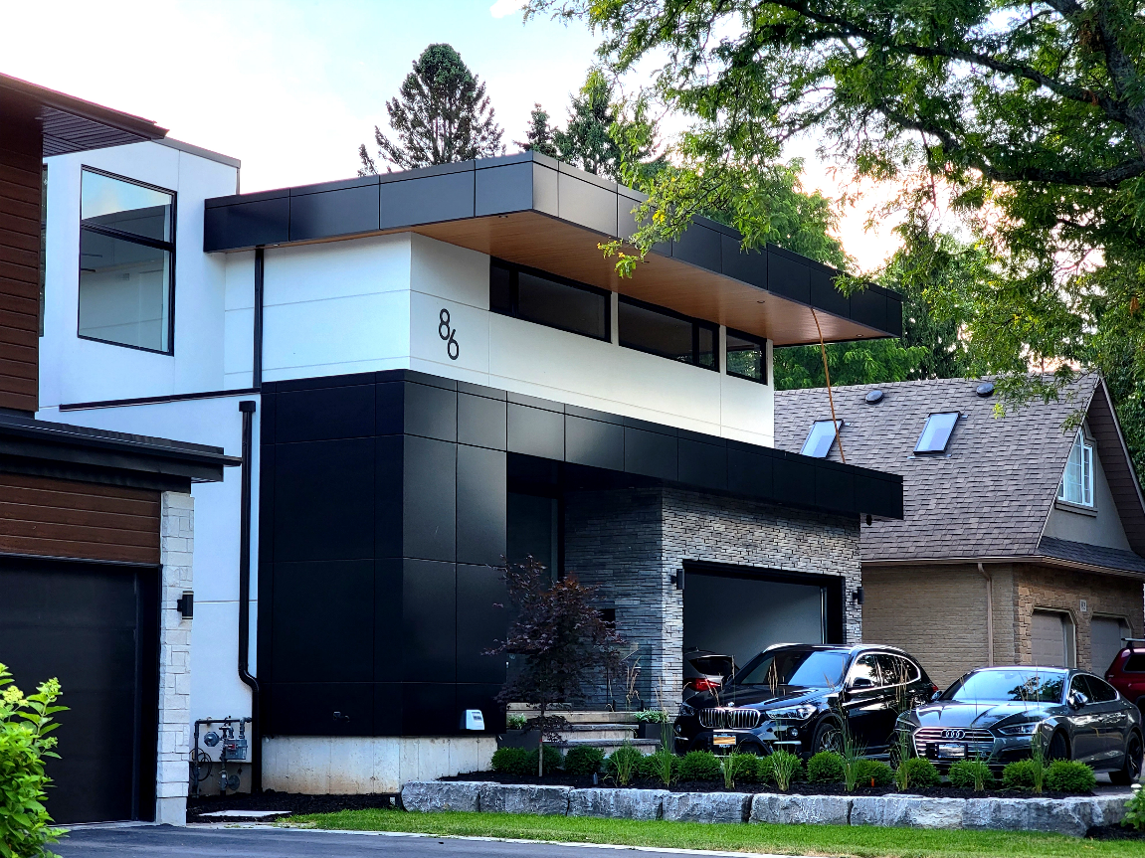
Industrial / Residential / Commercial / Agricultural
Designed in Canada. Built for Every Surface
uPVC vinyl siding offers the perfect blend of cost-effectiveness, durability, and aesthetic appeal, making it a preferred choice for homeowners and builders. Engineered to withstand fading, exceptional impact resistance, ensuring durability in various conditions. It minimizes heat buildup, repels water absorption, and remains impervious to bacteria and mold, making it a long-lasting, low-maintenance solution for a wide range of applications with a fresh, polished look and minimal upkeep.
Available in a variety of colors, textures, and profiles, vinyl siding allows for versatile design options to match any architectural style. Its lightweight construction ensures quick and easy installation, providing a high-performance, long-lasting solution for both renovations and new builds.

Architectural Cladding for Every Surface, Inside and Out
Transform your space with CladCan’s versatile uPVC panel systems engineered for walls, soffits, ceilings, beams, and columns. Whether you’re drawn to the crisp lines of V-Groove, the depth of U-Channel, or the bold elegance of the Shadow Series, our durable, low-maintenance profiles offer realistic wood or metal looks for any residential, commercial, or industrial application, indoors or outdoors.

DUAL-PROFILE CLADDING PANELS- ICON
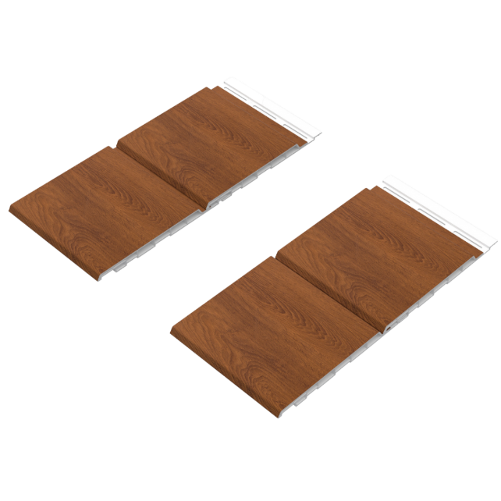
Two Looks, One Smart Panel
Get twice the design flexibility with the dual-profile panel—crafted for seamless horizontal, vertical, or diagonal installations...... (Learn More / Expand)

DUAL-PROFILE CLADDING PANELS (EXPANDED)
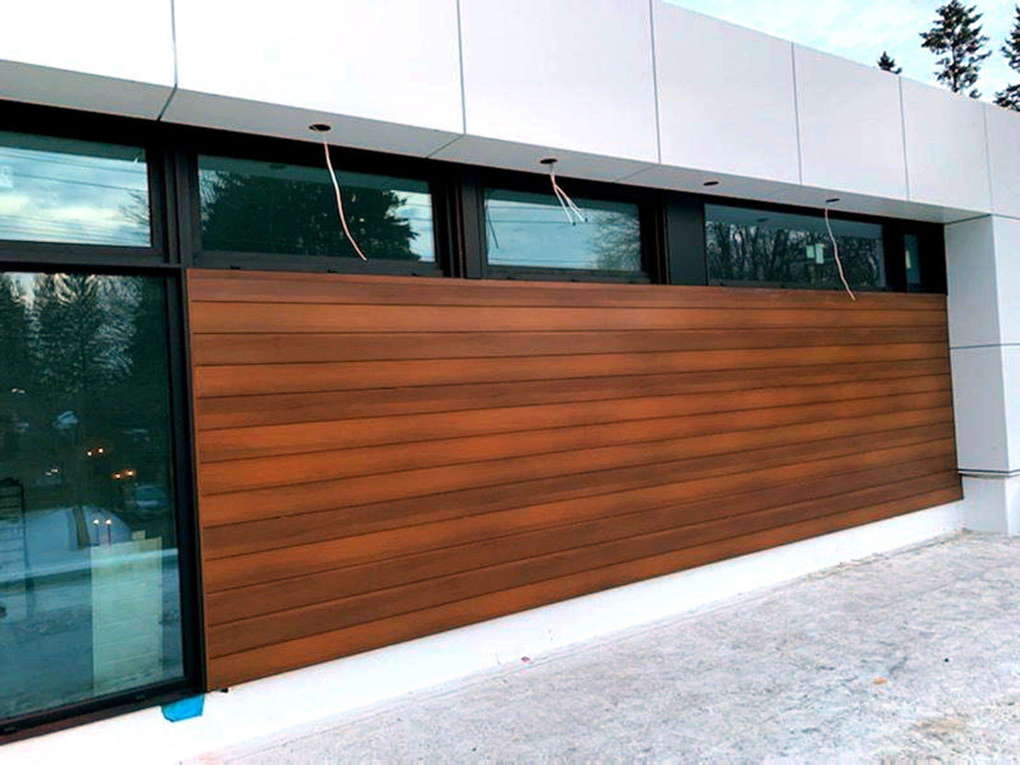
Expanded … Sleek, Defined, and Maintenance-Free
Get twice the design flexibility with the dual-profile panel—crafted for seamless horizontal, vertical, or diagonal installations.
Dual-Profile panels are designed to maximize design flexibility while minimizing complexity. With two unique profiles built into a single panel—U-Channel and V-Groove—you can achieve multiple visual styles using the same product, saving time, cost, and effort on site.

U-Channel
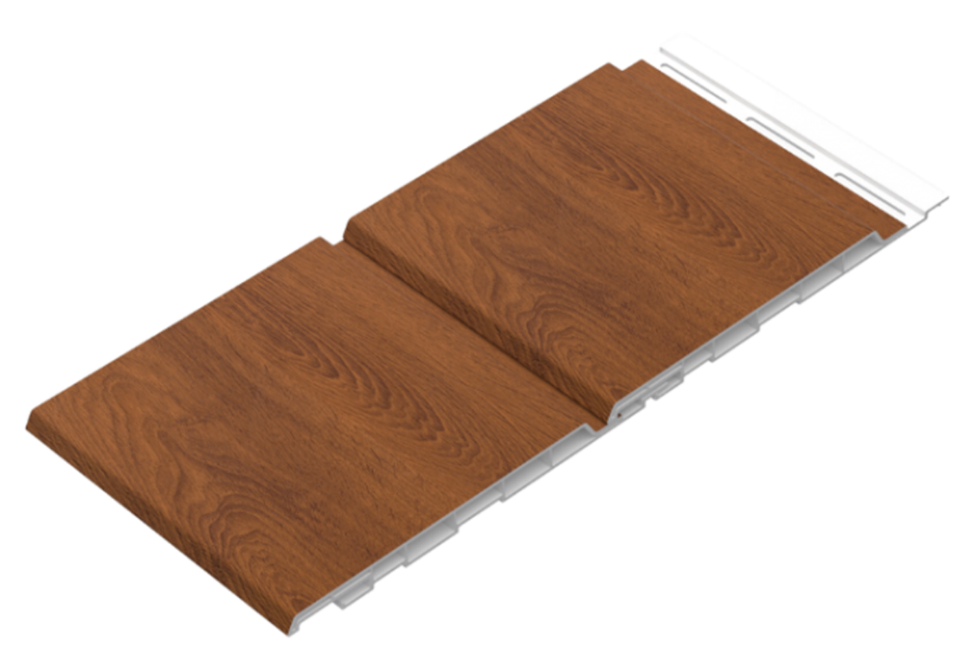

V-Groove
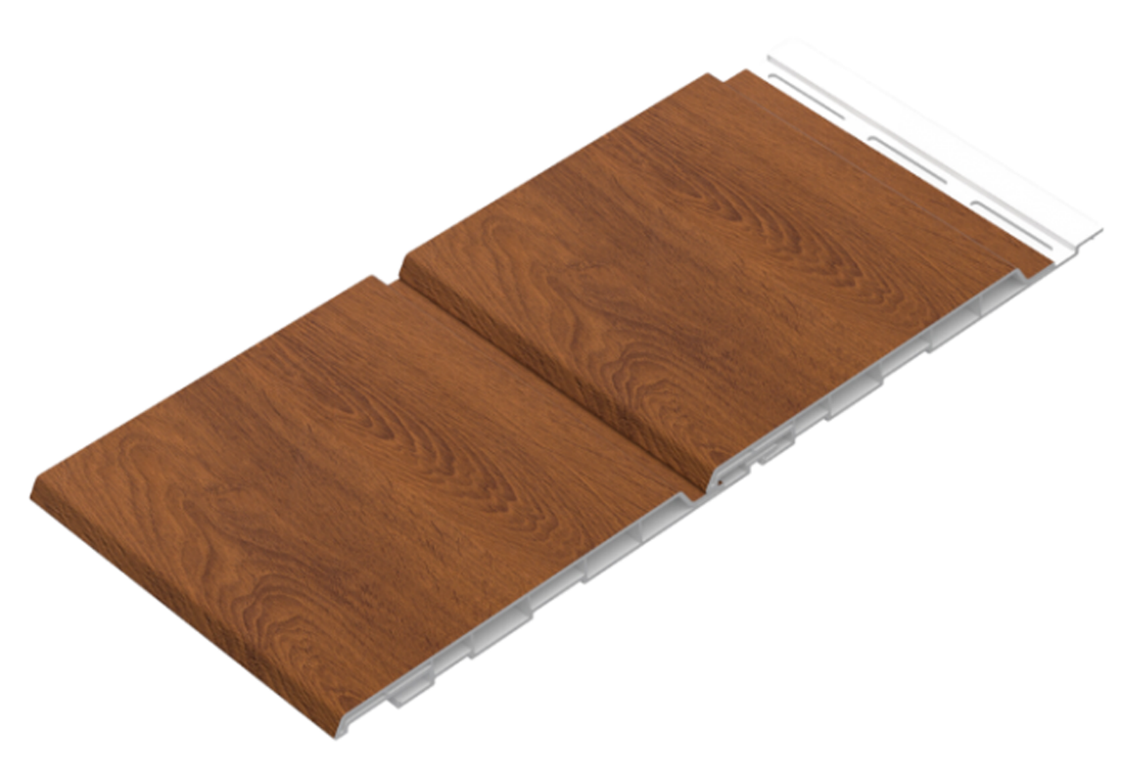
Whether you’re installing exterior siding, soffits, interior feature walls, or commercial façades, this versatile uPVC panel brings a high-end architectural finish that suits both modern and traditional design concepts.

Simple Installation with a Smart Stacker System
The panel features an engineered tongue-and-groove locking system, commonly known as the “stacker system.” This intuitive design allows installers to adjust the look during installation with just a few simple steps:
• For a U-Channel profile, align and stack the panel at the first stop.
• For a deeper V-Groove appearance, gently tap the panel to the second stop using a non-marking rubber mallet.
This precision-fit system ensures clean, uniform lines and makes horizontal, vertical, or diagonal installation fast and straightforward—even across large surfaces.

Designed for Performance and Built to Last
Dual-Profile panels are manufactured from durable, low-maintenance uPVC and are engineered for Canada’s climate. With UV resistance, impact durability, and moisture resistance, these panels won’t crack, fade, or rot—making them an ideal alternative to traditional wood or metal cladding.
The product is also sustainable, made from recycled content, and 100% recyclable—meeting the needs of eco-conscious builders and developers.
With the Dual-Profile panels, you’re not just choosing a cladding material—you’re choosing design freedom, long-term durability, and architectural elegance that stands out.
Key Features and Benefits
• Two styles in one panel: U-Channel + V-Groove
• Install horizontally, vertically, or diagonally
• Quick and secure tongue-and-groove system
• Low-maintenance and weather-resistant
• Ideal for residential, commercial, or industrial projects
• Available in a wide range of realistic woodgrain and designer finishes
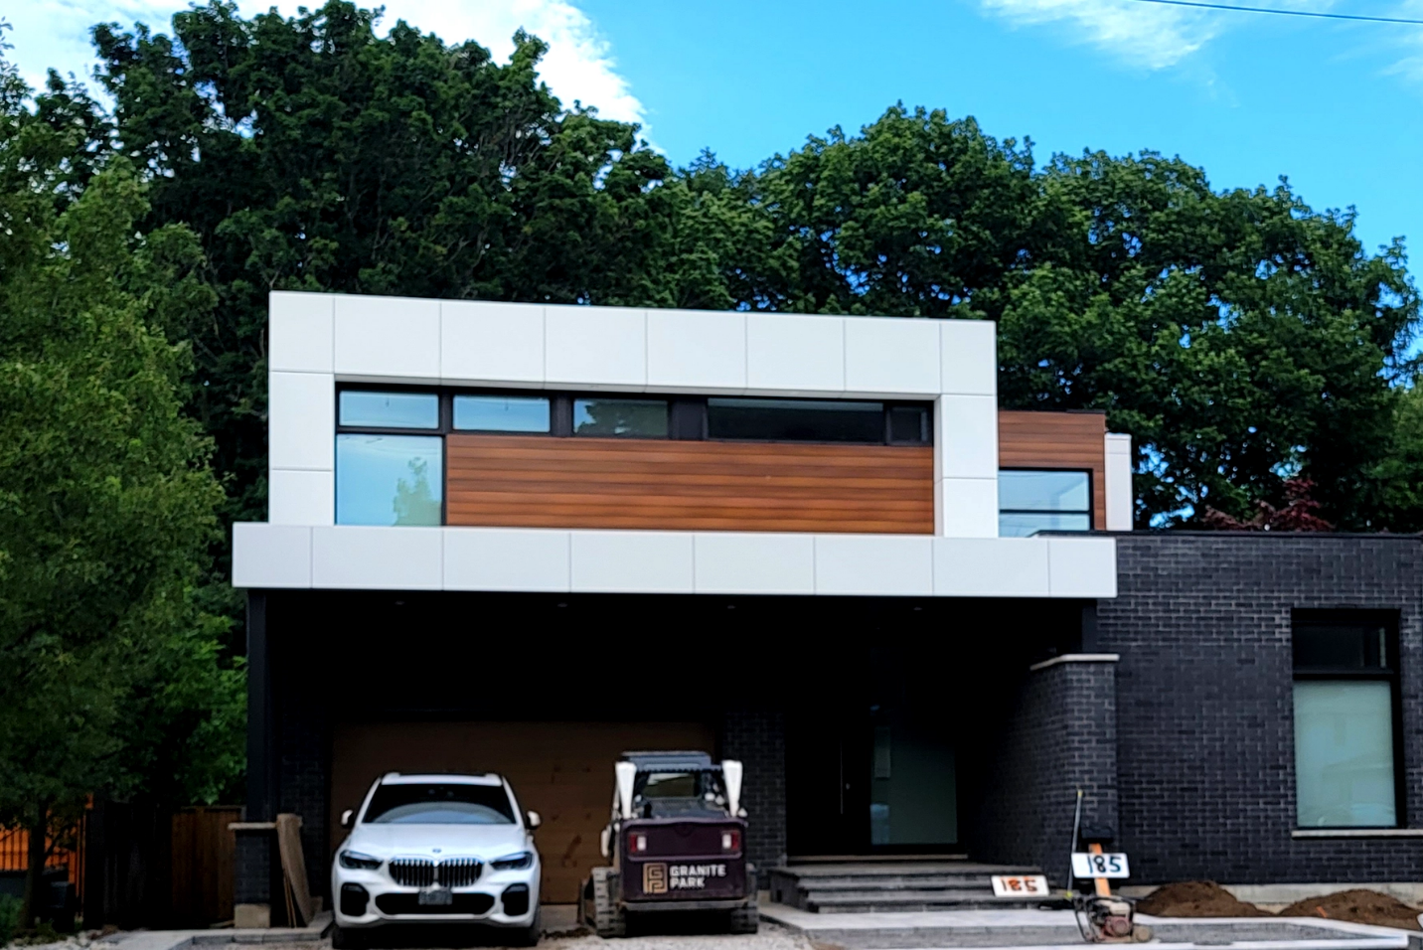
Here’s why builders, designers, and property owners across Ontario are switching to premium uPVC:

Stylish. Sustainable. Built for Canadian Conditions.
uPVC panels deliver a winning combination of elegance, performance, and low maintenance. Here’s why builders, designers, and property owners across Ontario are switching to premium uPVC:
Canadian-Made Quality
Proudly manufactured in Canada for unmatched quality, consistency, and local support.
Weather-Resistant Durability
Built to endure harsh winters, UV rays, and moisture without warping, cracking, or fading.
Low Maintenance, Long Lifespan
No painting, staining, or sealing needed—just install and enjoy for decades.
Indoor & Outdoor Versatility
Ideal for interior walls, exterior façades, soffits, beam wraps, and accent panels.
Modern Style Designs
Premium finishes in woodgrain or solid colours to suit both classic and contemporary projects.
Fast & Easy Installation
Lightweight and designed for quick fastening—perfect for efficient builds and retrofits.
Eco-Friendly & Recyclable
Made with recycled materials and fully recyclable, supporting green building practices.
Fire, Impact & Pest Resistant
Tough and resilient, uPVC panels are engineered for long-term use in any environment.
Great for Residential, Commercial & Industrial Projects
Whether it’s a custom home, retail plaza, or warehouse upgrade, our panels fit the bill.
Speak with an Expert Get personalized advice and expert guidance to achieve your project goals with confidence.

Profile Details:

6” Dual-Panel
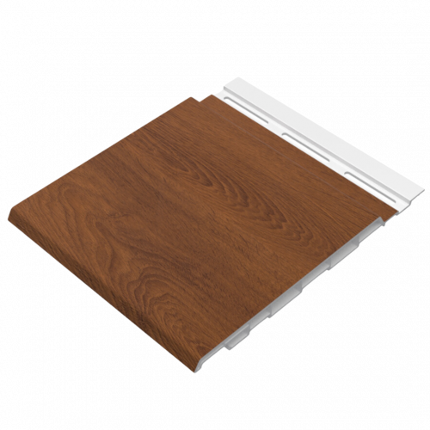

Material: Recycled Rigid PVC
Available Lengths: Solid - 12 ft, 16 ft, 20 ft and 30’, Custom Lengths Available
Profile Dimensions: 6” wide × 0.5” thick
Installation Options: Horizontal and Vertical
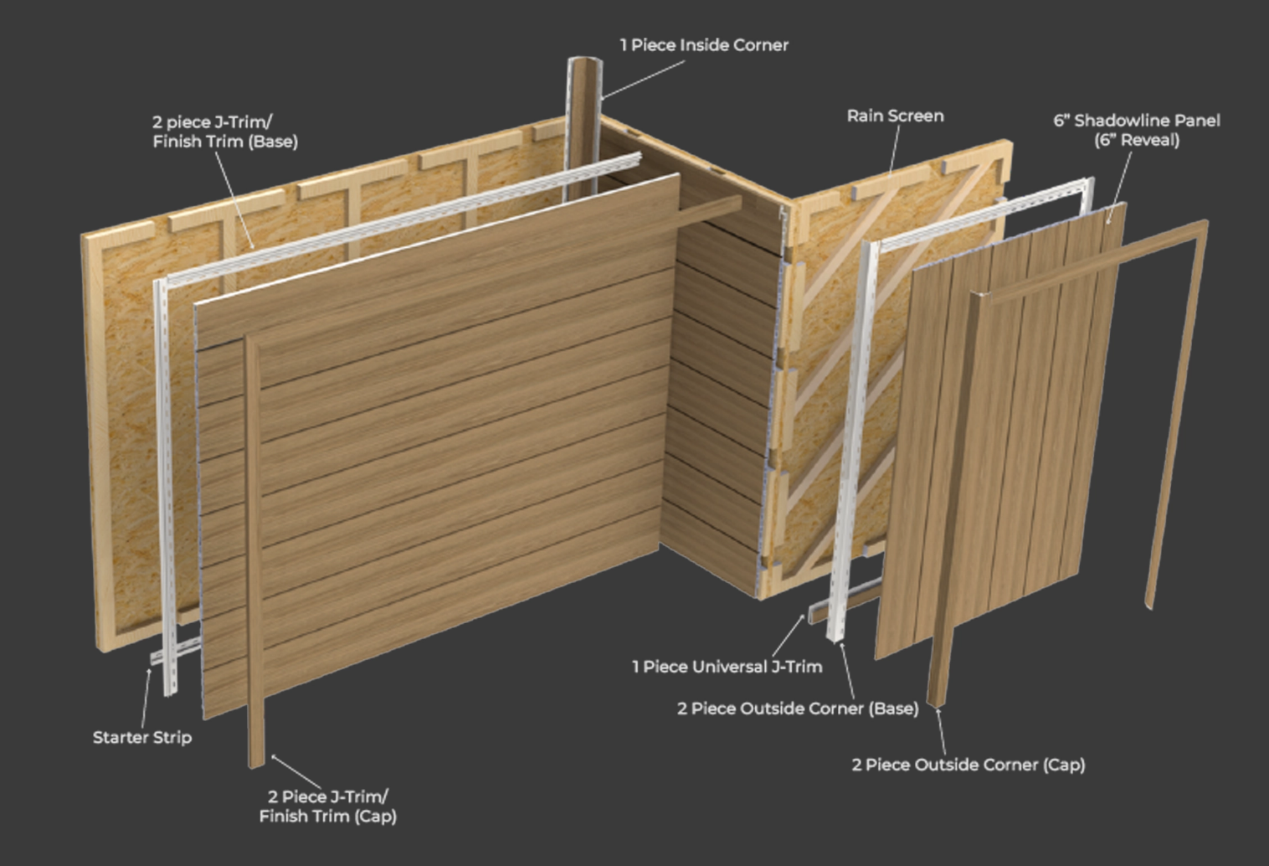

Trims
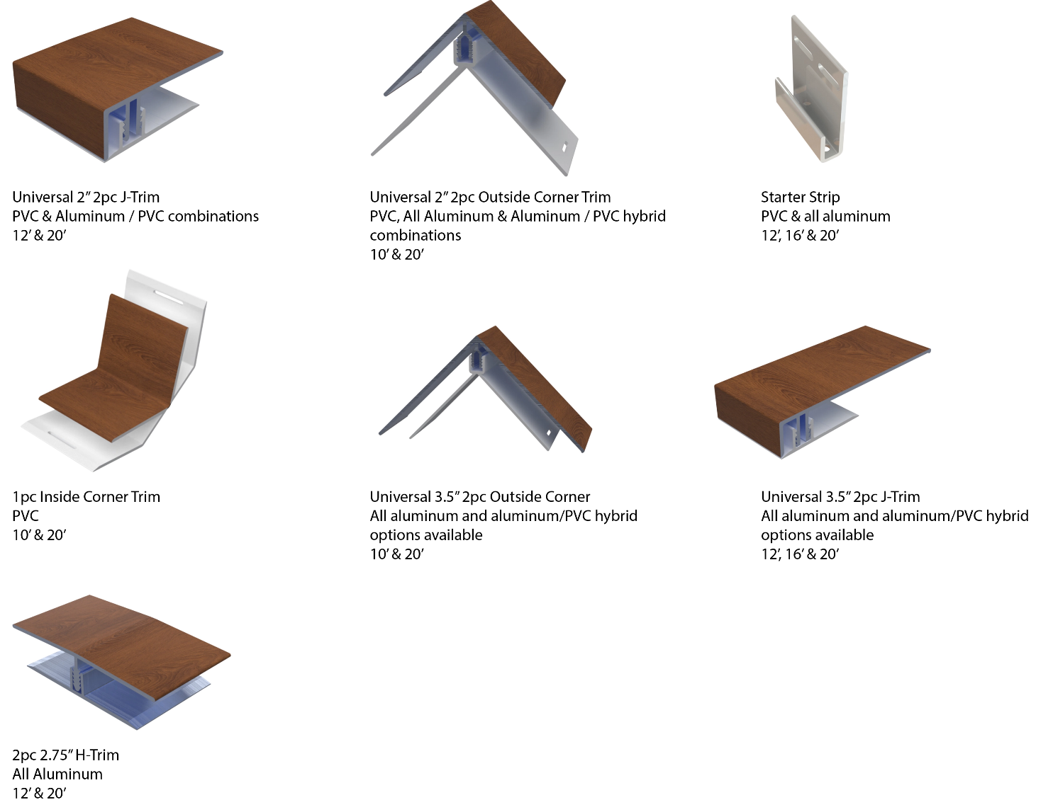

Stunning Finishes That Look and Feel Real
Authentic Textures. Lasting Performance. Designed to Impress.
Our extensive lineup includes rich woodgrains, sleek anodized looks, bold solid tones, metallic sheens, and elegant interior-specific finishes—each developed to meet a wide range of design needs.
Crafted using advanced film technology, many of our finishes feature a high-performance polyvinylidene fluoride (PVDF) top layer. This ensures long-term durability, superior UV resistance, and exceptional colour stability in all environments.
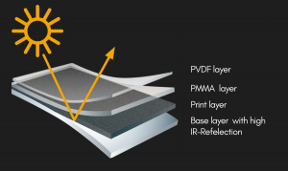
What sets these finishes apart:
- Heat-reflective technology for cooler surfaces and longer lifespan
- Embossed textures that simulate the natural feel of wood and other materials
- High pattern variation to avoid repetition and create a more organic look
- Matte and textured options for modern, high-end aesthetics

Whether you’re designing a modern exterior or an elegant interior feature, CladCan delivers finishes that look as good as they perform.

Looking for something specific?
Get in touch for our full catalogue of available finishes and custom options.

Woodgrain Finishes
6” Dual-Panel

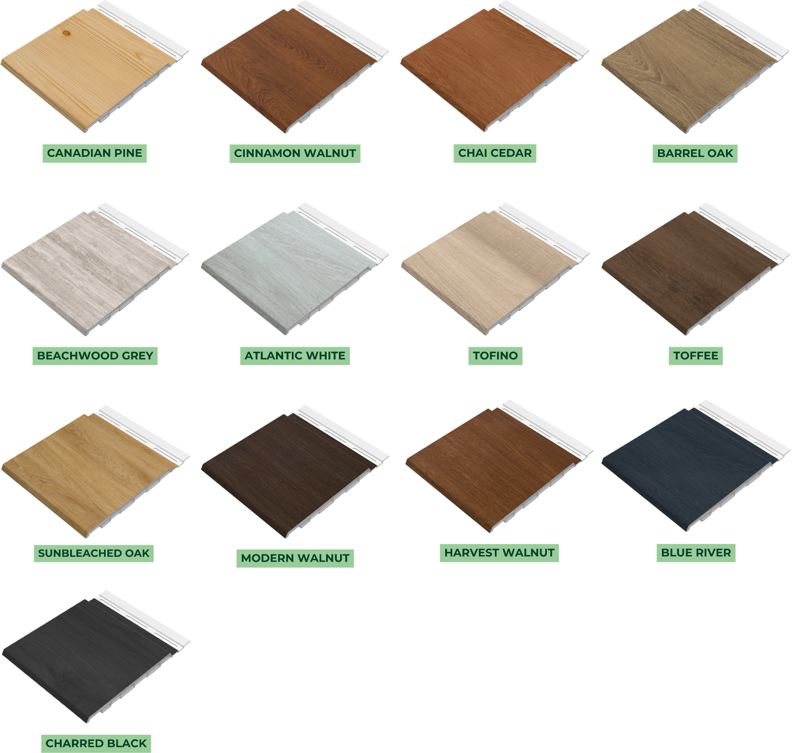

Solid Finishes
6” Dual-Panel

